

Room on the Broom
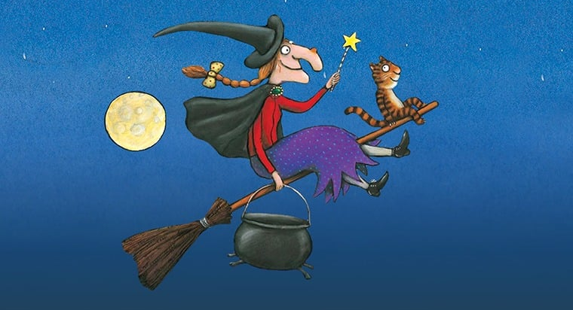

On Thursday 30th October 2025

Scunthorpe Fire Station 10:00am
Scunthorpe Central 1:30pm

On Friday 31st October 2025

Brigg Community Hub 10:00am
Baysgarth Community Hub 1:30pm

Join North Lincolnshire Libraries
for the reading of Julia Donaldson’s classic tale.
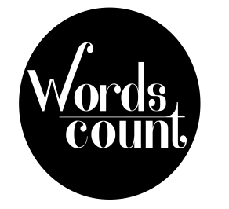
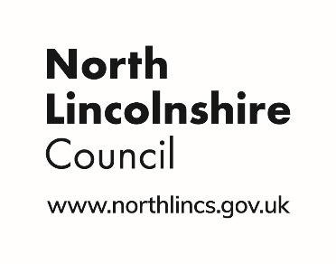
No need to book
All Welcome

