How do coastal cities vary around the world?
Understand geographical similarities and differences through the study of a region in the United Kingdom, a region in a European country and a region within North or South America
Key Vocabulary
Headland | A coastal landform created due to erosion when the sea attacks a section of coast with alternating bands of hard and soft rock
Bay | A broad inlet of the sea where the land curves inwards
Plymouth | A City and major port in England
Boston | A City and major port in North America
Calais | A City and major port in France
Human Geography | Geography concerned with Humans and their interactions with the natural world.
Physical Geography | The branch of geography dealing with the natural world.
Natural Harbour | A landform with a protected section of water which is deep enough for ships.
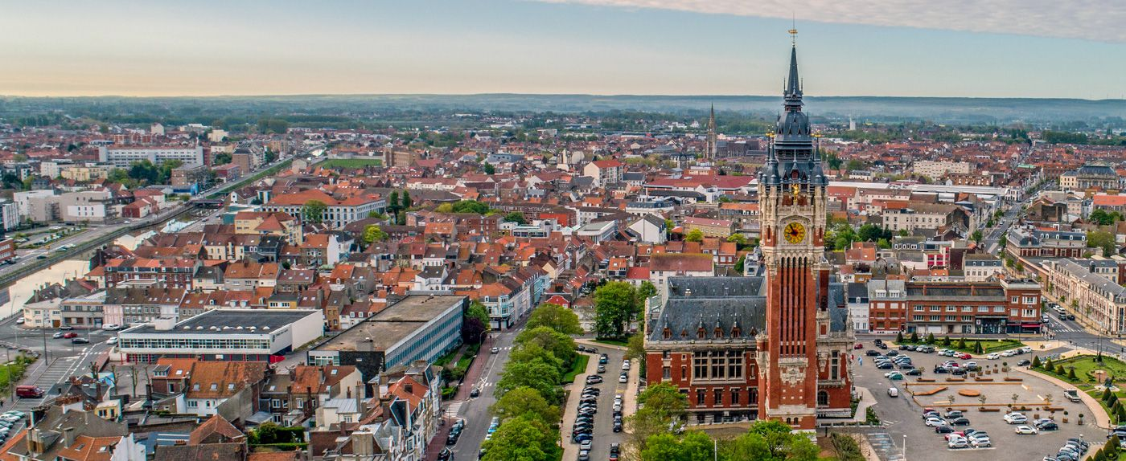

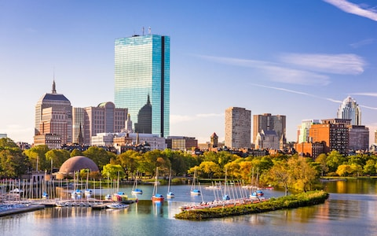
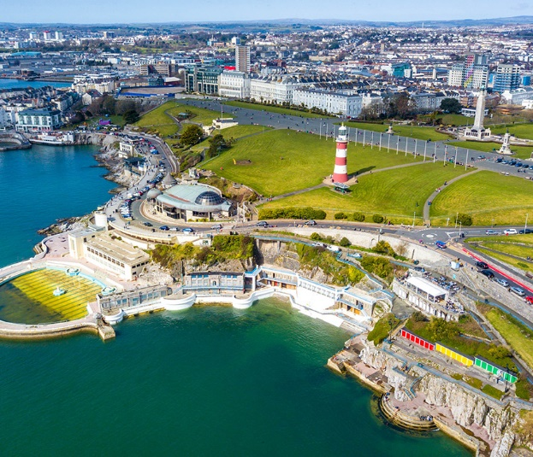
Calais
Calais overlooks the Strait of Dover, the narrowest point in the English Channel, which is only 34 km (21 mi) wide here, and is the closest French town to England.
Plymouth
Plymouth is a port city in South West England. It is located on the south coast of Devon and is bordered by Cornwall to the west and south-west.
Boston
Boston officially the City of Boston, is the capital and most populous city of the Commonwealth of Massachusetts in the United States and 24th-most populous city in the country.

